Wifi Beacons

We have a data file with captured wifi frames. Using that file, analyze the file and answer the following questions

* Find the beacon frame for the wireless network. What’s the SSID? Include a screenshot showing you found the SSID

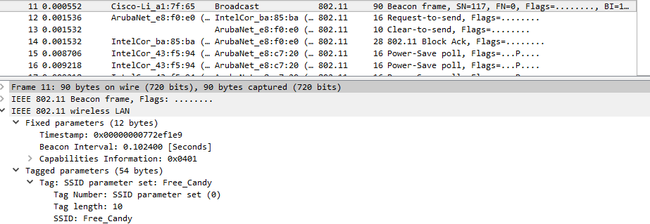

Free_Candy

* What is a Beacon interval? With wifi, what is the absolute minimum and maximum value for the beacon interval?

.102400 [seconds]

* What type of wireless network is broadcasting? Show a screenshot that shows how you found out.

802.11b

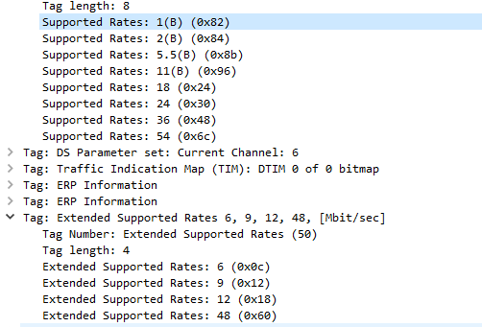

* What encryption, if any, is the network using?

None

* With the beacon frame, the device is manufactured by Cisco (Linksys), but Cisco did not actually make the radio in the base station. Who did?

Broadcom

* Of the many values in this beacon frame, one of them isn’t actually required by the access point. It could be blank/empty. Which one is it?

ERP

* The BTS in this beacon supports “short time slots”. This setting is enabled. Find the setting (byte) in the beacon frame that indicates this and include a screenshot. What does this value indicate? What impact does it have on a network?

https://i.gyazo.com/e4bac86d4981592a23cfdf9bfee1d891.png

Short Slot Time indicates that the time between communications is reduced, increasing throughput. All clients must also be capable of keeping up with this pace.